**Sessums Summer Reading BINGO**

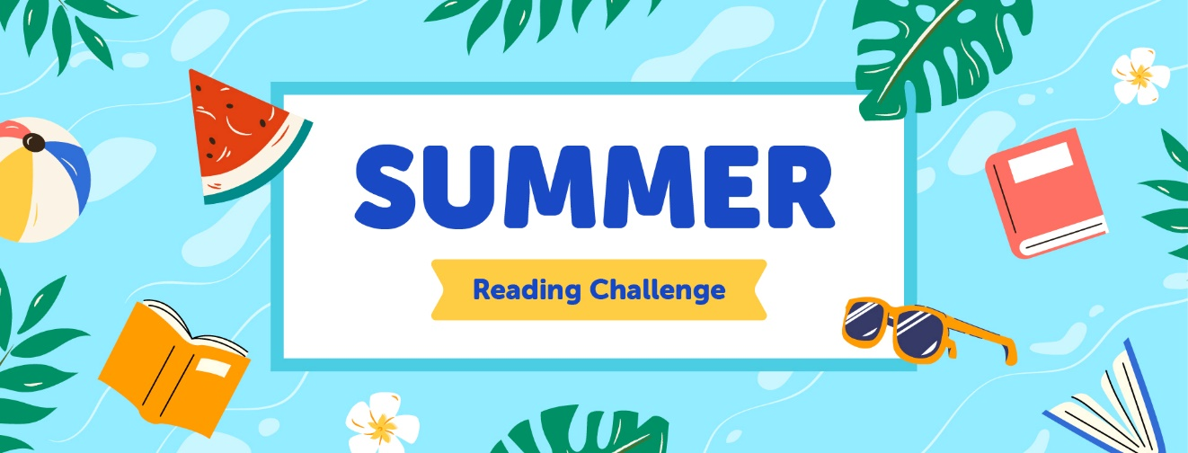

**This summer we will be using Beanstack to track reading and earn badges/prizes. Beanstack can be accessed through their mobile app, by using your child's ClassLink account (HCPS Hub), or use this link:**[**https://www.beanstack.com/find-a-site**](https://nam04.safelinks.protection.outlook.com/?url=https%3A%2F%2Fwww.beanstack.com%2Ffind-a-site&data=05%7C02%7Cteresa.hester%40hcps.net%7Ceefde03a0fb8414472b408dc7604a013%7C10a8fdf9c2ff4e0d9c191fe2c188164a%7C0%7C0%7C638515009444606918%7CUnknown%7CTWFpbGZsb3d8eyJWIjoiMC4wLjAwMDAiLCJQIjoiV2luMzIiLCJBTiI6Ik1haWwiLCJXVCI6Mn0%3D%7C0%7C%7C%7C&sdata=CEaJSk50uMYfX1iQjZBR9zGZimQOy50zvLl9Bqj7lyw%3D&reserved=0)**.**

**When your child logs their reading minutes, they will earn badges to complete their BINGO board. When they earn one BINGO, they will win an animal topper gel pen. If they completely fill out their BINGO card, they will be invited to a Library Games Party. All prizes will be awarded in August. This reading challenge begins May 25th and runs through July 31st. The Summer Reading Challenge will automatically appear on your child's account so there is no need to register. Just log in and start tracking!**